# Signs of God's Love

I want to begin this post by trying to put my feelings into words. It is so HARD to try to have joy at the same time as you are experiencing deep pain and sadness. It is difficult to celebrate a birthday at the same time as getting some terrible news over a phone call. This week has seen some high highs and some low lows. One thing is beginning to become more clear through it all: God and Jesus Christ love us and they want us to know it. We might see it through something subtle, like a kind and compassionate look from the caring eyes of a family member or a friend. We might feel it as a piercing, yet peaceful feeling during a portion of a song. It might even be something surprising and beautiful that we see in nature, that causes us to feel like this moment was meant just for me, and me alone. Some refer to these experiences as "tender mercies". In other words, it is a gift from a Kind and Loving Father who has compassion on us and all that we are going through, and also wants us to recognize that He is right there by our side through it all.  Whatever you want to call it, we have experienced this multiple times in the past few days.

At some point I will be able to share more of what is happening. But for now, I am like a sponge and I am ready to learn how to navigate through all kinds of feelings in the coming weeks and months. I hesitate to write about all the fun that we've been having with company over the last 8 days, knowing that some people are suffering and having a hard time. I feel so guilty, like that I'm being insensitive to post the good times that we've had. But the problem with that is that this life is not meant for endless suffering. We are meant to have joy! We can have joy in SPITE of our suffering. We can have joy in ADDITION to our suffering. And we can have joy at the SAME TIME as we are suffering. There have been many tears shed this week, but we went out into nature many times and we also felt joy. We smiled. We laughed. We joked. We celebrated.

Maybe that's the whole point. Fuel up because you're going to get depleted. Fuel up again. Get depleted again. Fuel up with wholesome things, the things that really truly matter in life. There will always be something to deplete that. So you fuel up again. And again. And again. Keep fueling up. Keep looking for those things that matter most and let them be your premium fuel. Just keep fueling up. Don't ever give up.

So . . . here we go . . .

We have had a wonderful week hosting Gordon and Pam, Scott's brother and his wife, from West Virginia. They flew in last Monday around noon, and we have been packing a LOT in this week, ha ha.

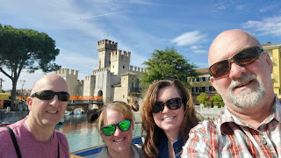

Monday:

In addition to the four of us, we fed the sister missionaries for dinner. I tried a new recipe that seemed simple in both ingredients and the time required to make it. We made Hasselback Caprese Chicken, a salad with FLOWERS on top, some white AND green asparagus, crusty bread for dipping in olive oil and rose balsamic vinegar, and a variety tray of desserts.

After I criss-cross cut the chicken breasts, Pam inserted slices of tomato along with some sliced fresh mozzarella into the slits.

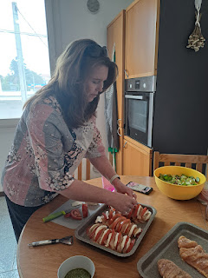

When I went to the grocery store that morning before they flew into Venice, I saw these gorgeous EDIBLE flowers next to all the bags of salad. They were too pretty to pass up, especially when I wanted a nice welcoming dinner for our company.

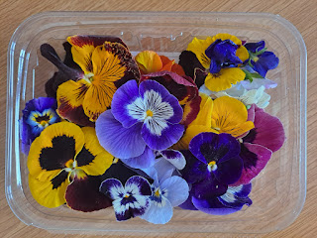

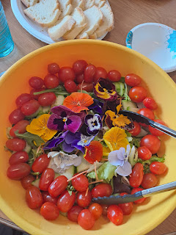

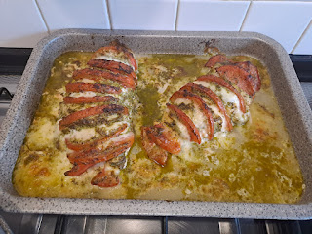

The chicken turned out great! Here is the recipe:

https://www.eatingwell.com/recipe/261639/hasselback-caprese-chicken/

When I was at the grocery store, I realized that I wanted something for a dessert, but wasn't sure if I would have the time to make something. I grabbed a few random desserts out of the refrigerated section, and then cut them all up into little portions so we could try more than one thing.

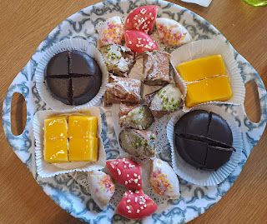

We all loved the mango cheesecake (orange squares) and the canoli (bite sized portions in the center, with chopped pistachios on top). There were also 2 donuts that I cut up and 2 chocolate dome cakes that had a tiny drizzle of caramel in the center.

Gordon took a 2.5 hour nap in the afternoon while Scott went back to work, and Pam bravely stayed up until around 9:00 p.m. and then she slept HARD through the entire night.

Tuesday:

We got up early and were out the door a little after 8:00 a.m. to drive to Sirmione, a darling little town on the southern peninsula of Lake Garda.

The tulips were nearing the end of their blooming season, so we were lucky to catch them before they turned pitiful. The flower beds were in a grassy area that lined several parking lots leading up to Scaligero Castle.

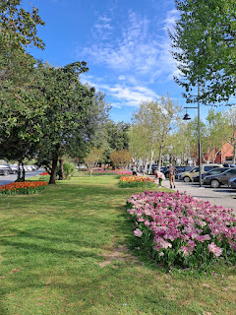

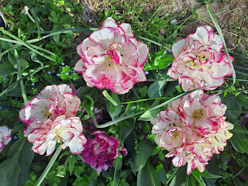

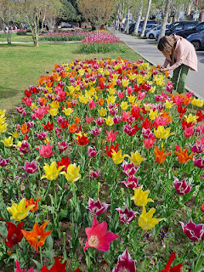

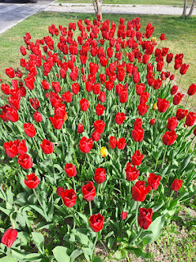

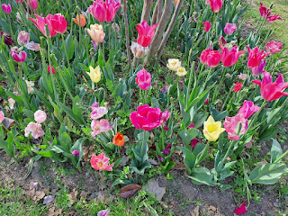

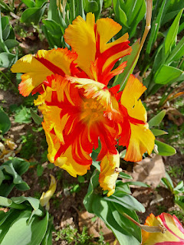

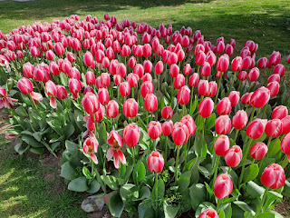

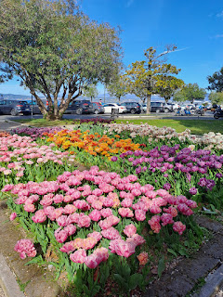

The day was sunny and blue and beautiful at the Lake.

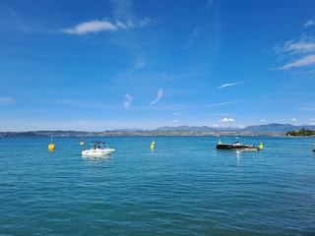

I enjoyed watching the smooth navigation skills of this guy, as he finessed his very sleek and fancy boat into the docks next to the castle.

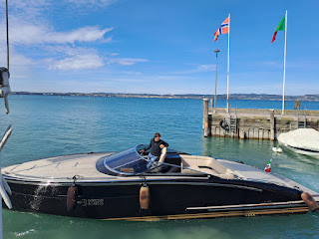

Just outside the entrance to the castle, I saw the largest lemons I've ever seen in my life!! We came back to this same place as we left the castle area, so that Scott could buy some kumquats (his favorite).

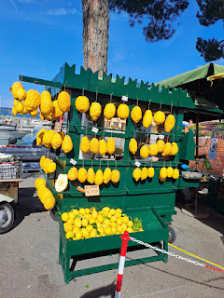

Plenty of work was being done to update, renovate, and beautify Scaligero Castello.  This lady was smoothing some type of mortar into the cracks, then scraping off the excess, and brushing the crumbs away. Tedious and time-consuming work, but as a visitor, I am grateful for all the love and attention that these workers put into their artful efforts.

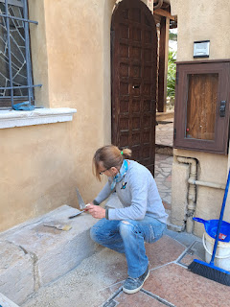

Scaligero Castle

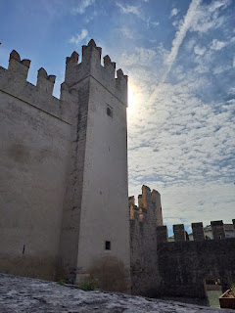

Scott, Me, Pam, and Gordon

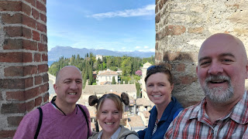

Beautiful views from the Castle . . .

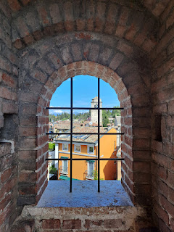

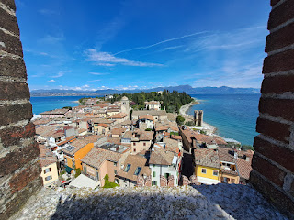

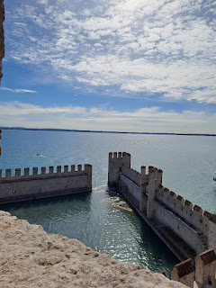

We saw some ancient headstones that were discovered in the Castle in 1919 when some extreme renovations began. The one on the lower left was from the early 1800's while the one on the far right (leaning up against the wall) was from 1539.

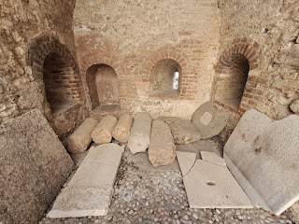

After our castle tour, we walked through town to get over to Lido Jamaica Beach so we could walk around the point of the peninsula.

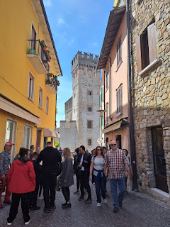

Somebody left some decorative cairns out on the beach for the rest of us to enjoy.

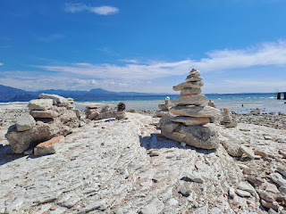

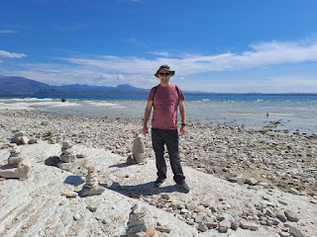

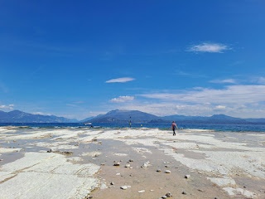

Scott and Gordon watching a duck swim by . . .

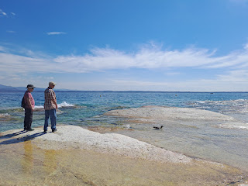

Gordon wanted to get his feet wet . . .

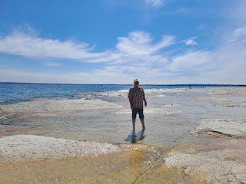

Video of Gordon wading along: (12 seconds)

https://photos.app.goo.gl/8YkkmMwt3r1BqRNu5

Roman ruins up on the cliffs at the most northern point of the peninsula.

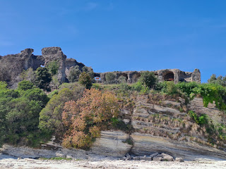

Coming back into town . . .

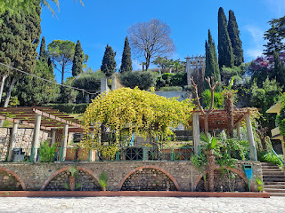

We had a tasty lunch near the castle. Gordon and Pam shared a Margherita Pizza, Scott had a grilled cheese sandwich, and I had a crispy chicken sandwich. It was all very good.

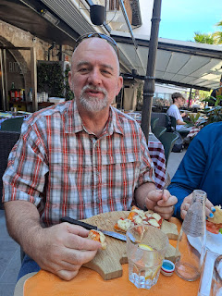

On the way back out to the car, I noticed another grouping of tulips that I had missed as we went in earlier.

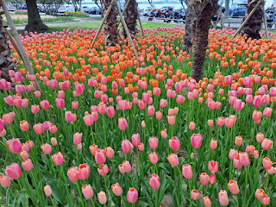

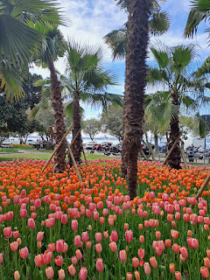

Yay!! Scott got some fresh kumquats so he was VERY happy.

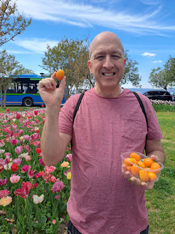

After we left Sirmione, we drove about an hour ENE to get to Molina, which is north of Verona. It's a tiny little "town" out in the hills. We went to visit the Molina Waterfall Park for the first time, and it is definitely a place we will go again. (Especially to bring visitors)

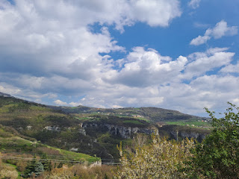

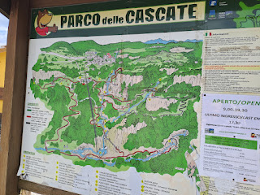

We only had time to follow most of the red path, although we went in a reverse direction from what was recommended, ha ha. We didn't do the red path on the left of the map, but we just did the middle and right sections. We had to hurry home for a Relief Society dinner that evening . . .

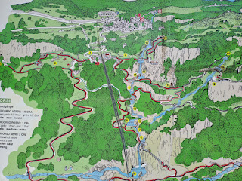

From where we parked, it was a steep downhill most of the way down into the canyon where the park begins. We walked through the very deserted town of Molina and we tried to come up with reasons why nobody was home . . . like that maybe they all work in a bigger town during the day, and they just weren't home yet. There were a few evidences that people do live there, such as flowers sitting in a windowsill, or on a porch, a garden recently tilled, etc.

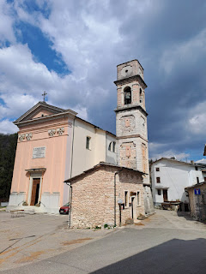

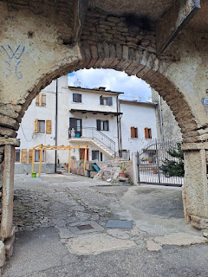

We walked past this cute little park on the left, and then at the opposite end we saw a very interesting sign.

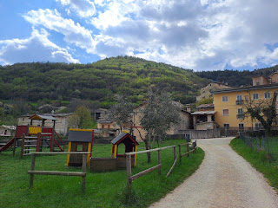

"Centenarian Park: After celebrating appropriately, we have planted a tree for every villager of Molina who has reached 100 and counting! With the help of the fresh air and the beauty of Molina, we are looking forward to welcoming many new trees."

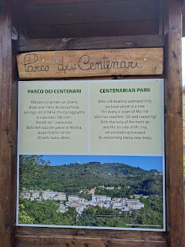

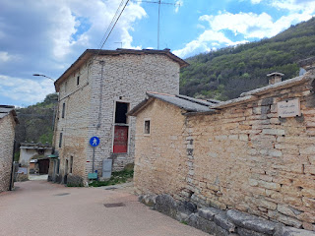

I did a little research about Molina and this is a good link that shares some of its history:

https://parcodellecascate.it/en/park/the-historic-heritage/

Apparently, Molina is a VERY old mill town, tracing back to the 10th century. It makes sense, now that I think about it, because of its proximity to so many streams and rivers.

After wandering through town, with plenty of signage pointing the way down toward the waterfall park, we began to follow the path out through some pastures and orchards. All of it was so beautiful!

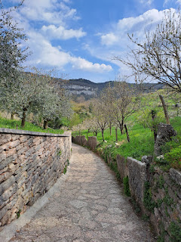

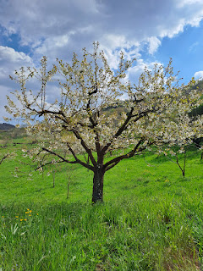

We paid for our tickets and entered the park, in awe of the forests, streams, large rocks and cliffs, and waterfalls.

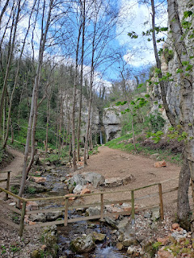

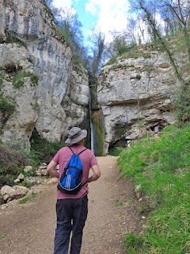

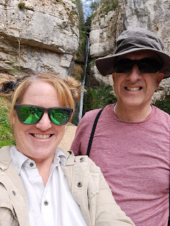

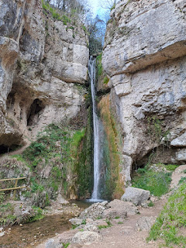

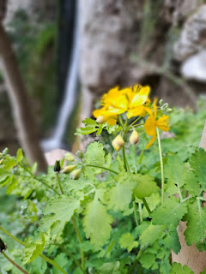

This sign explained the significance of the caves surrounding this waterfall. They found Neanderthal remains here . . .

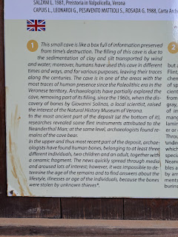

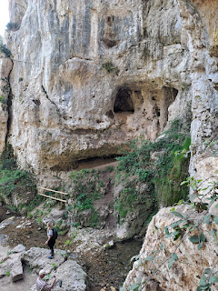

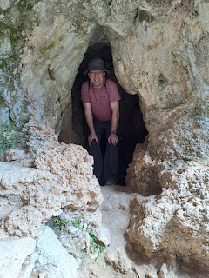

There were many types of wildflowers along the pathways and even some growing out of the rocks.



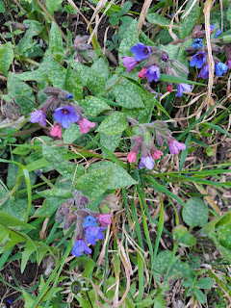

Video of one of the waterfalls: (18 seconds)

https://photos.app.goo.gl/YZgzk76b6E9aPJrV6

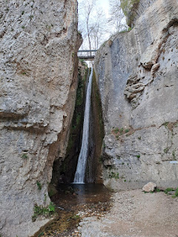

Some "comfy" stone seating around a "picnic table" . . .

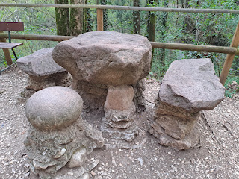

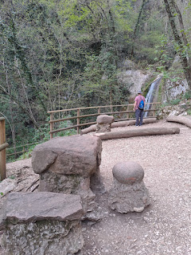

First Gordon climbed up the stone tower, then he challenged Scott to do the same. You know how brothers are . . . ha ha

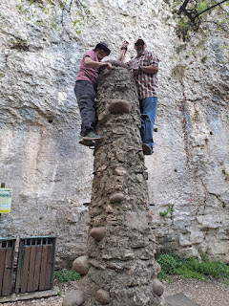

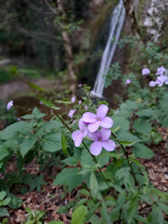

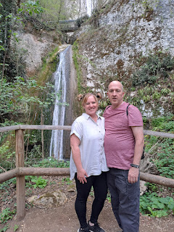

Awwwww. How sweet.

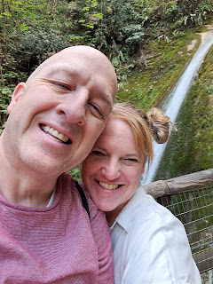

We had to stop and consult our maps several times to make sure we were staying on the red path and making the best use of our limited time before we needed to head home.

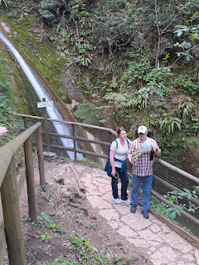

Video of another waterfall: (9 seconds)

https://photos.app.goo.gl/pg8UMffdM5yzwrZf8

Video of another waterfall: (17 seconds)

https://photos.app.goo.gl/NoyRX1FJ3DFRdgPY6

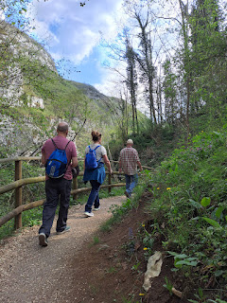

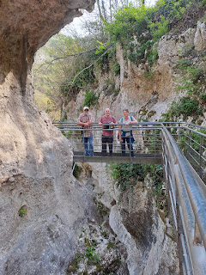

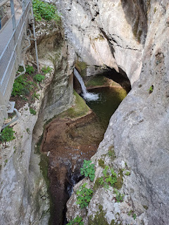

I thought of my sister, Charmaine, numerous times as we hiked down in the canyon. There were many signs explaining this plant or that plant, this tree or that tree, and I knew she would just be in heaven here.

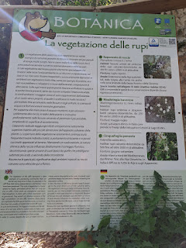

Another interesting tree for Charmaine . . .

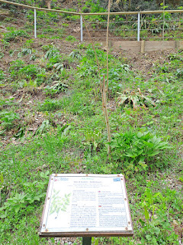

Gordon and Pam taking a selfie in front of a waterfall . . .

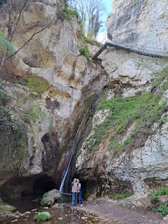

The views from in the canyon looking up . . .

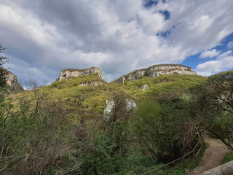

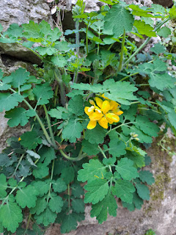

Then we had the loooong trek back up all the steep pathways to get back to our car . . .

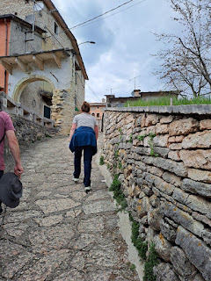

Back through the deserted town one more time . . .

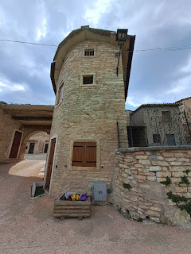

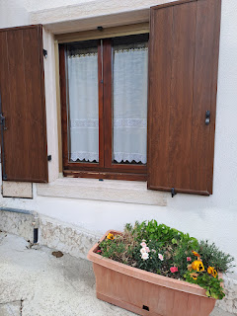

It was a little over an hour to get back to our house. The hurry we were in all day was because there was a very interesting Relief Society dinner and activity that evening at Angie Wilson's house. Paolo and his wife, Julie, attend the Italian Ward in our same church building. (They meet at 9:00 a.m. and we meet at 11:00 a.m.) Paolo is a professional chef and baker and was willing to teach us how to make a few very simple Italian meals that are fast and inexpensive.

Paolo is in the black shirt and red apron below, and his wife Julie is behind him in the white floral shirt.

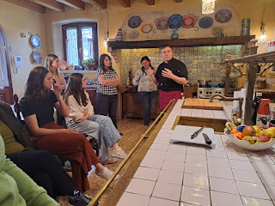

The first meal he cooked for us involves these ingredients: diced ham, peas, cream, and pasta. He mentioned later that you don't have to use canned peas, but you could use frozen peas. (Yes, please!)

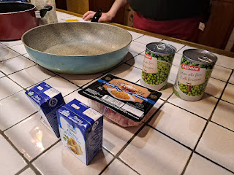

You cook up the diced ham - - here in Italy it's more like a bacon. Then add in the peas (drained) and cream. Lastly, stir in the pasta that you've cooked separately, and voila! You have a tasty meal in about 10-15 minnutes.

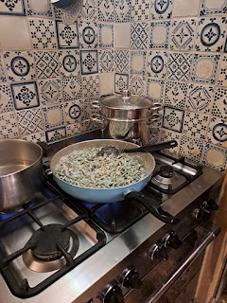

He used long, slightly curly noodles that were made with spinach, so that's why you see so much green in the photo above.

He also taught us something very interesting about the different colors of pasta that we see in the stores. The whiter the pasta, the better quality it will be, but also more expensive. The more yellow it is, the less quality it will have, but it is also the cheapest.

When the pasta is being made and is going through the drying process, the longer it sits, the whiter it becomes, which deepens the flavor and quality overall. The pasta that is more yellow has been whisked off much sooner and doesn't have as much quality, kind of like when you see underripe tomatoes in the grocery stores vs. homegrown tomatoes with a richer and fuller flavor.

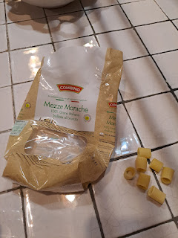

The next dish consisted of pasta, white beans (like canneloni or great northerns), tomato sauce, fresh basil and fresh mozzarella.

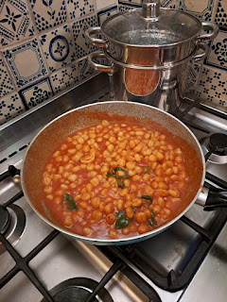

Video of Paolo stirring the pan of pasta: (15 seconds) *Angie's dog Kimber is anxiously awaiting for a taste, LOL

https://photos.app.goo.gl/MzL6ivBcQ9nrJRZJA

Video of Paolo tearing up the ball of fresh mozzarella into pieces for the dish: (20 seconds)

https://photos.app.goo.gl/avMwqL9xAEbE7QKJ6

The last meal he made for us was my favorite. But I was so full at that point that I could only eat a few bites . . .

He showed us a product that they have in the Italian grocery stores - and he said it is a staple at their house. It consists of diced onions, carrots, and celery. They use it as a base for soups, sauces, casseroles, and many pasta dishes. You can even just sautee it up and serve it with chicken over the top.

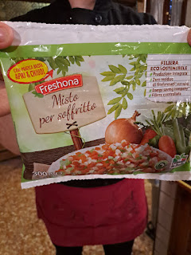

This is essentially ground pork. He talked a lot about how this is so much better for you than processed pork, etc.

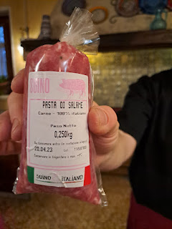

I didn't get any photos of the tomato sauce that he used, but over here it's called Passata and it's amazing. To me, it's not just a smooth tomato sauce like what we see in the cans from the U.S. Passata is slightly chunkier and has more texture and is SO FLAVORFUL. It's like a tomato sauce and tomato paste together in one.

After the veggies and pork were cooked up, he added in some long pasta called Tagliatella. It was SO GOOD. Again, all of these meals were ready in about 10-15 minutes. Granted, they are all PASTA based meals, and I don't eat pasta very often because they are loaded with carbs, but I could see doing this once in a while. Or as a side dish to accompany something with much lower carbs . . .

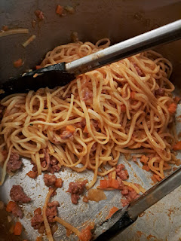

Pam enjoyed coming to the activity with me and we had a good time with all the other ladies.

Wednesday:

We drove up to Asiago instead of hiking the Road of 52 Tunnels. Pam's hip was bothering her a little and so we decided to do something a bit less strenuous. Not 15 minutes into the drive, we ran into a wonderful surprise!!

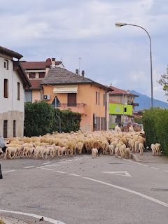

A MASSIVE herd of sheep and goats were being shepherded through the middle of one of the tiny towns that are just outside of Vicenza. (Caldogno) We just happened to be driving through a roundabout at exactly the right time to see it all unfold. It was one of the coolest things I've ever seen!!

Video of the sheep, goats, horses, and donkeys trotting through town: (1 minute, 29 seconds)

https://photos.app.goo.gl/PinyKqB5NjGrd4d58

It takes about one hour to get up to the top of these mountains surrounding Vicenza. Asiago is up at the top, but on the other side. Scott and I went up there last fall and hiked all over the countryside. That's when we fell in love with Asiago and vowed to bring as many of our guests up there as possible.

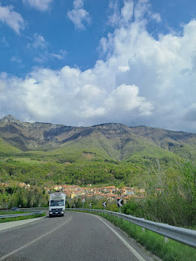

Lots of hairpin turns . . . but Scott is really good navigating through those.

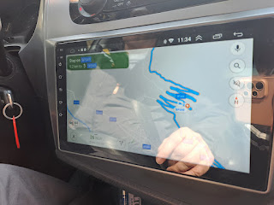

We stopped first at Pizzeria Da Tata, where we ate last time in Asiago. I just love the whole fried egg experience on top of my pizza. It's pretty fun!

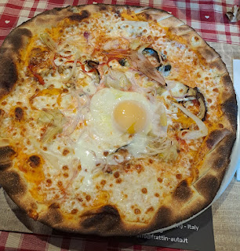

There was a sweet older lady behind us, who clearly had dementia. Her kids still took her out to eat and helped cut up her food. There was also another family that brought their special needs son, who is wheelchair bound and can't talk. I remembered seeing them last fall when we ate here, as well. I love seeing life unfold in Italy in much the same ways as they would in the U.S. Again, there's that thread of trying to incorporate joy into your life where there is also sorrow or difficulties.

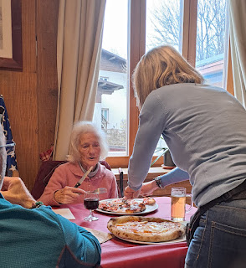

After lunch, we walked around town a little and over to the WWI Monument. It was closed for Italian Riposo (like a Mexican siesta every weekday afternoon), so we chose to walk for an undetermined amount on a trail that was adjacent to the Monument.

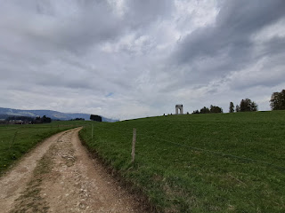

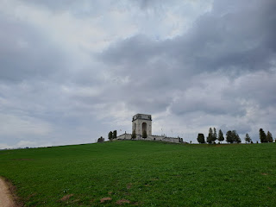

Rain threatened us the whole afternoon, but didn't give us too much trouble overall. It was definitely cold, though!

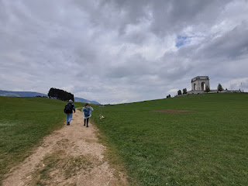

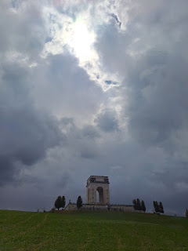

Gordon and Pam :)

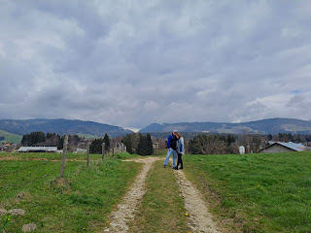

I'm not sure how Italians are able to get a good crop in when there are so many chunky rocks in the soil. Maybe they plant a larger grain, like corn. I would like to learn more about that. The fields were plowed so nicely, in spite of all the chunks.

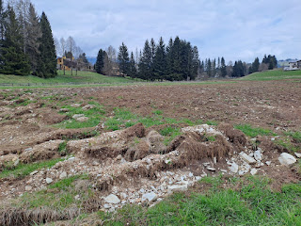

On our way back into town, there was a little "booth" of sorts where you could pay your respects to Mary, the Mother of Jesus. You could leave a beaded necklace, or flowers, etc. I'm not sure who supervises the tiny little shrine.

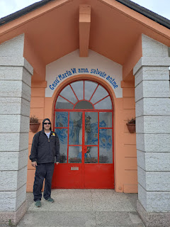

I enjoyed seeing all the flowers in bloom, the patriotic spray-painted woodpiles, and beautiful architecture on our walk through Asiago.

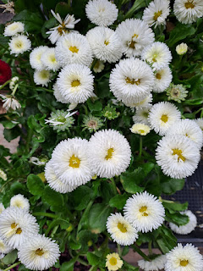

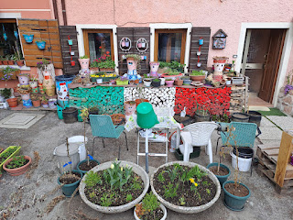

You can even see the WWI Monument off in the distance . . .

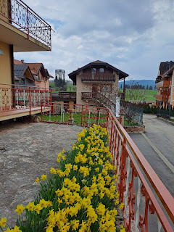

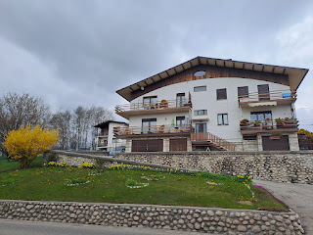

St. Matthew the Apostle Church was very beautiful, both inside and out.

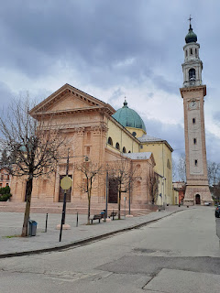

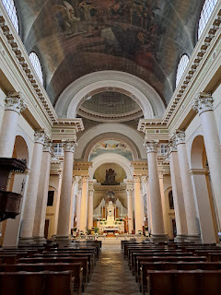

The original church goes back to the 14th century, but it got destroyed in WWI. In 1926, it was rebuilt on the same spot and stands proudly today.

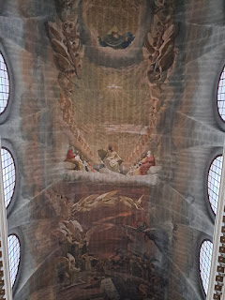

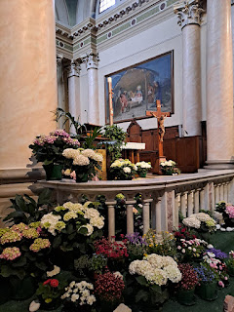

Gordon and Pam taking it all in . . .

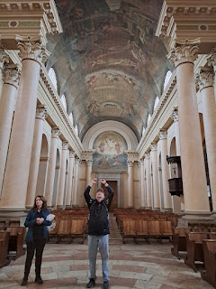

I especially liked this scene of Joseph, Mary, and young Jesus together as a family.

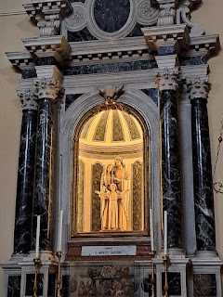

Gordon looked a little remorseful as he came out from the confessional booth, LOL (nobody was actually in there scolding him  . . .)

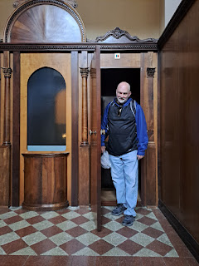

We split up for a while at this point. Gordon and Pam went for a walk to find some gifts for family members, while Scott and I just lazily walked around the streets surrounding the church until we got too cold. That's when we went and sat in the car where it was a little warmer. It was a very cozy place to hang out.

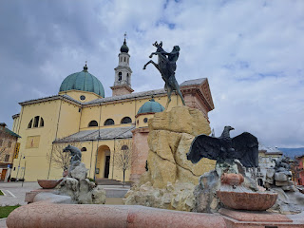

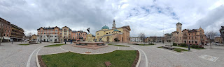

We found a monument tucked in the corner of a street, so we went closer to investigate. Turns out it was a monument dedicated to Antonio Gnatta, a 17 year old boy, who was killed on 7 August 1944 on that very spot.

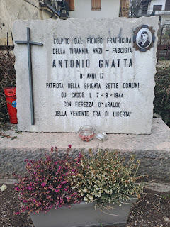

There was a series of plaques with the story and testimonials behind the memorial. Scott took a photo of one of the plaques and used Google Translate to read us the story of what happened to Antonio. (see below) (click the photo to enlarge)

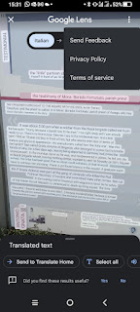

How sad and tragic, but how beautiful that the townspeople are keeping his memory alive.

Some other random things from the middle of town . . . 250 days until Christmas apparently . . .

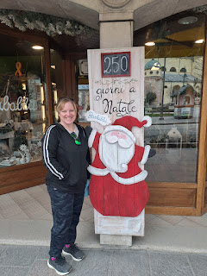

Window shopping . . .

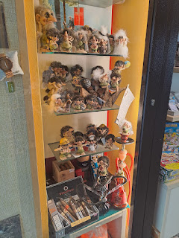

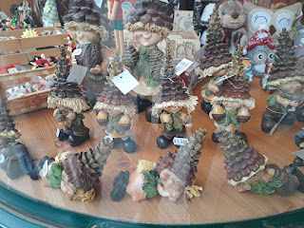

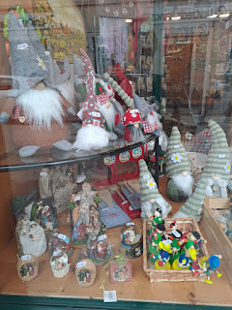

I also took pictures of the Millepini Park in Asiago, where we want to bring Jack next week. I sent Jacob and Hannah several pictures so they could know what is available there. We have been researching several different parks and it will just be a matter of narrowing them down, because we can't see them all, unfortunately.

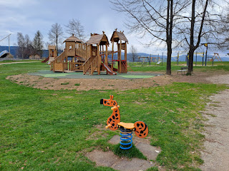

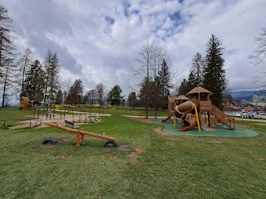

Our last stop before we left town was to visit the cheese shop and get some fresh local cheese. We stopped at a different place than where we went last fall. This place was quieter and they spoke some English, which was super helpful. It was called Premiato Caseificio Pennar. They had some cute little gnomes in the corner . . .

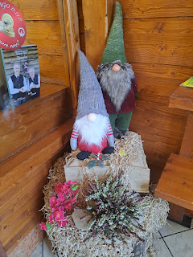

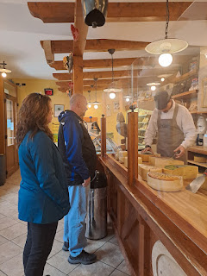

They had butter, cream cheese, milk, and several varieties of cheeses to select from.

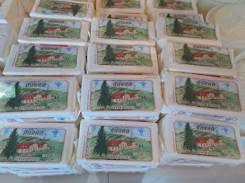

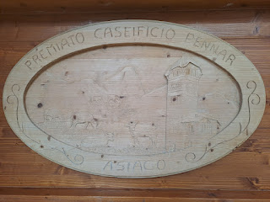

And a large cowbell hanging from the rafters . . .

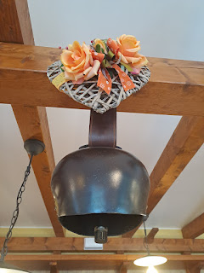

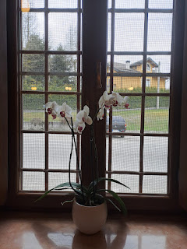

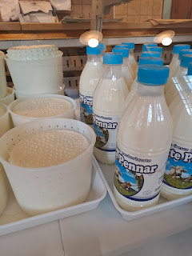

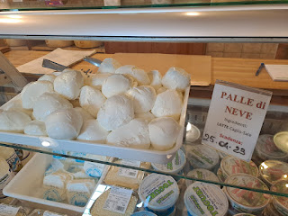

The young man behind the counter was so patient as he gave us several samples to taste.

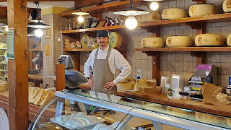

Video #1: He is cutting a block of cheese in half and packaging it up for us. (10 seconds)

https://photos.app.goo.gl/Aj6p8BebghtpuNpJ7

Video #2: He is slicing up a sample piece for us to nibble on. (5 seconds)

https://photos.app.goo.gl/vDhzuuKaMoa6XQvM7

One more thing from Asiago - I saw this in a storefront window and I used Google Translate to help me understand what the celebratory event was all about. (click to enlarge the photo) Very interesting . . .

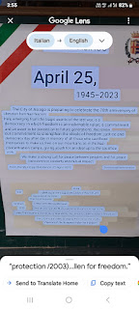

Soon after we got home and had some dinner, we caught the bus over to downtown Vicenza so we could walk around and explore a little.

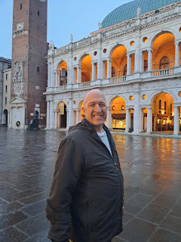

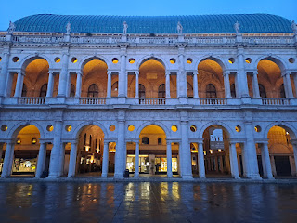

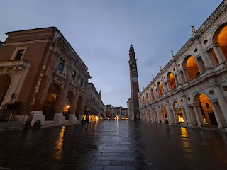

Video of a street performer, playing his saxophone: (17 seconds)

https://photos.app.goo.gl/CaedRTb9G5pXJe1k9

To be honest, I felt like a flop that night because I wanted to be a knowledgeable host and to be able to point out this and that and to be able to share some background information about each one, but I wasn't up to par. I was only able to point and say, "That's a building that Andrea Palladio built." I couldn't find a few things that I thought I knew where they were, and I was frustrated with myself. I felt like I was leading Gordon and Pam around blindly, and that perhaps everyone was confused and disappointed in me. But Gordon and Pam reassured me more than once that they were happy to just wander and soak it all in and not to worry. When we got home, Pam reiterated that same reassurance again, and it made me cry as she hugged me. I was able to release my own expectations that I had heaped on myself and to remind myself that I don't need to be perfect. :)

Thursday:

Happy Birthday Scott!!! He went in to work for the day, while Gordon and Pam rode the train to Padova on their own to explore for the day. That meant I had some time to prepare the food for my husband's birthday celebration that evening, as well as some time to work on my upcoming talk for church.

I made Slow Cooker Creamy Lemon-Herb Chicken and it was delicious! Here is the recipe that I used.

https://www.delish.com/cooking/recipe-ideas/a41886262/slow-cooker-creamy-lemon-herb-chicken-recipe/

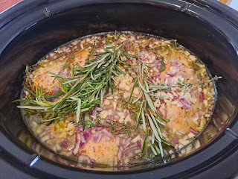

I also made something besides cake for Scott's birthday dessert. He has a profound love of peanut butter, and he eats at least one big spoon of PB every day. He even keeps a jar of PB at work so he can have a snack there, too. I looked for a recipe that would make a nice PB dessert and found this one. It's a peanut butter bar, with peanut butter icing, and chopped peanuts on top. Man, if you're a PB lover, this recipe is for you!

https://celebratingsweets.com/maple-peanut-butter-bars/

I didn't have parchment paper, but the recipe said that foil would work well too. The peanut butter bars are very dense, but so perfect! Everyone especially enjoyed the sea salt sprinkled on top along with the chopped peanuts.

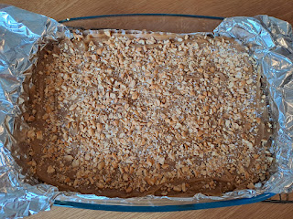

The moment of truth: he's about to open his card and BIG GIFT . . .

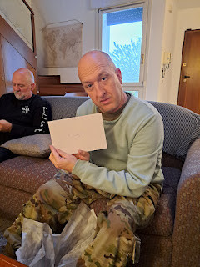

Video of him pulling his special gift out of the bag and then recognizing what it is: (23 seconds)

https://photos.app.goo.gl/m3KBpRQJwSHgpTdXA

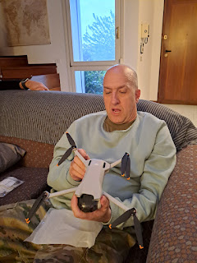

Here's the full story:

When Scott and I were walking around Lake Bled in Slovenia back in March, we saw two guys rowing across the lake, along with their friend who was manning a drone on the shoreline to video their progress. Scott said to me then, "That is SO COOL. I would LOVE to have a drone." I was surprised, but happy because it gave me a good idea to tuck away into my brain. I was thinking it would make a good Christmas gift for him.

But then, a few days later, when I was with Benson (before I flew to Louisiana for Easter & Abby's baptism), I mentioned the idea to him. He got SO excited because apparently he's been researching drones for some time now. So we started shopping online together right then and there. We even formulated a plan to order it in time for Scott's birthday on April 20th and that we could all get together on Saturday the 22nd with Gordon and Pam and visit the Dolomites before Benson leaves for Korea. Benson helped me decide on which brand and model to purchase, which was HUGE. I would not have known how to narrow down the search on my own . . .

The next big step was to order the drone. I waited until I got to Weston and Amber's house, so I could talk to Weston about it, too. We ended up ordering it through the U.S. Amazon and having it shipped directly to Weston's house, since it would be much faster than using the Amazon Italy. He ordered it using his own account so that Scott couldn't see what we were doing. (So sneaky)

The last big stress was getting it on the plane to go back to Italy. I was flying on Turkish Airlines for the first time, and their rules and restrictions were a mile long. Amber researched in depth for me on what the rules are for taking a lithium battery onto an aircraft. We were way under the limit for size of batteries and their capacity, so I breathed a sigh of relief. TSA said I could take it as a checked bag or as a carry-on. I was glad to have a little more confidence as I went to the airport on April 13th.

However, at the luggage dropoff area where you also check in for your flight, the guy checking me in told me I couldn't take the drone on the flight. I told him of the research we had done and that TSA said it was more than okay with the type of battery I had. He went to check with his supervisor . . . and then came back to let me know that I would have to speak with her as well.

I had to wait a long time for her to be available for me to speak with, and then she told me that it could not go on the airplane AT ALL. I started to panic at this point, thinking what in the world would I do if I had to ditch the drone in Dallas? I asked if she had a post office in the terminal, but she didn't know if they did or didn't. I explained all of the research that we had done and that TSA said it was okay per their guidelines. She had me get it out of my bag so she could take it into the back room and confer with her colleagues. I waited, and waited, and waited some more. Finally, she came back out and said that yes, I could take it on the plane, but it would need to be a carry-on. PERFECT!! I had borrowed a small carry-on suitcase from Amber and Weston for just such a purpose. (The reason they prefer things like this to be a carry-on is so that if the lithium battery starts smoking and having problems at a high altitude, at least people would see it while seated on the plane. If it was underneath in the cargo hold, nobody would ever see it.)

And THAT is the story of how Scott's birthday came to be, and how it almost didn't come to be. This was also the day that we got the phone call with very devastating news. It was really hard to try to celebrate his birthday when we were all very sad at the same time.

Friday:

This was a shopping day and a day to slow down a little. I took Gordon and Pam to the Piramidi Mall and the Palladio Mall in Vicenza so they could find some gifts for family and also for themselves.

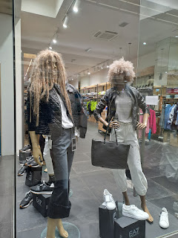

When Scott got home from work later in the afternoon, we drove up to Aviano to spend the night.

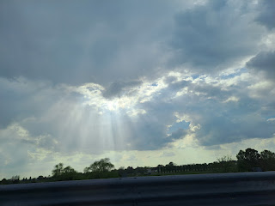

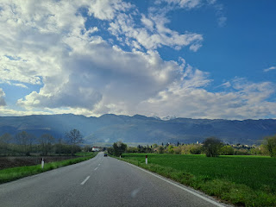

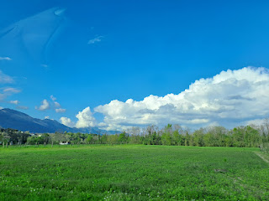

Below is the view from our hotel room at Hotel Oliva. It lived up to its 9.2 stars out of 10 rating. They were extremely welcoming and helpful at the front desk, spoke excellent English, it was a great location in the center of town, and they had a phenomenal breakfast, all for just $85.

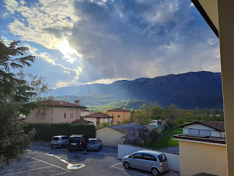

The reason we had a sleepover in Aviano is so we could be closer to Benson for our drive into the Dolomites the following day, since he would be coming with us. We took him out to dinner at BeFed, a popular restaurant in town. It was so good to be with him again. :)

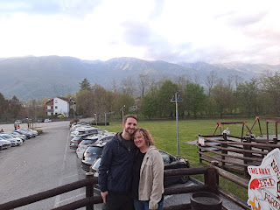

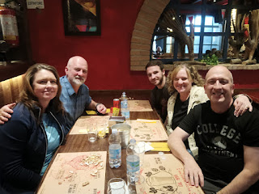

Saturday:

We headed out early, since we had a 2.5 hour drive ahead of us. After a spectacular breakfast spread, we hit the road northwest.

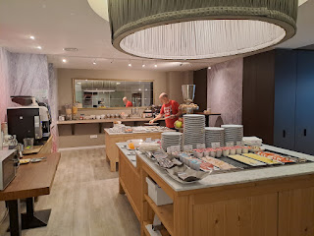

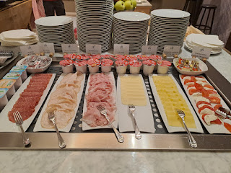

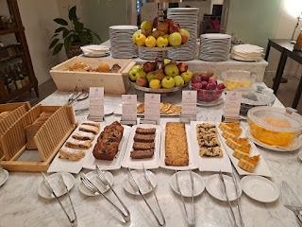

The drive was exceptionally beautiful.

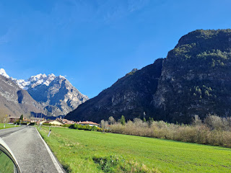

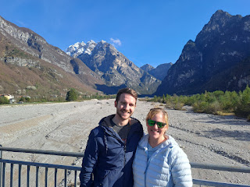

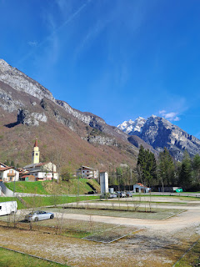

We paused for a bathroom stop and to get out the drone and see if we could figure it out, since there was plenty of flat area to work with.

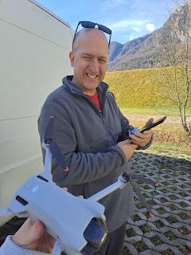

We tried and tried, but could not get the drone to "pair" with the controller. We spent over 30 minutes working on this issue, but finally we gave up so we could get going again.

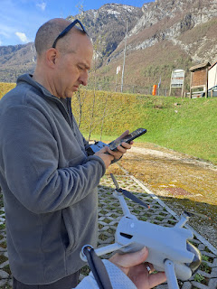

Benson was a great assistant, trying his best to diagnose what the problem was.

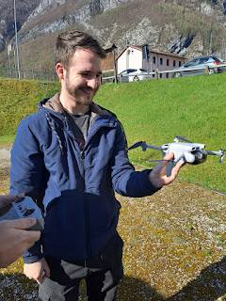

As we drove some more, Benson was in the back seat with me, trying to still figure out how to fix the pairing issue.

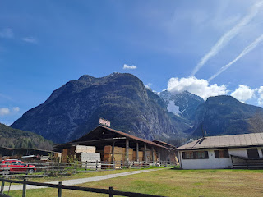

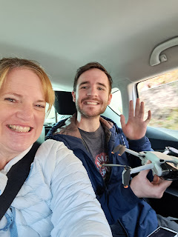

He noticed that there was a firmware update that needed to be done, and that task alone eventually fixed the problem!! Way to go Benson!!

Our next stop was at Auronzo, where there was a beautiful dam and the most gorgeous color of water in the lake. It was sort of a teal/deep turqoise color.

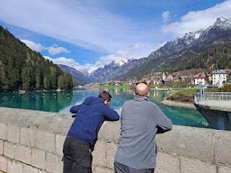

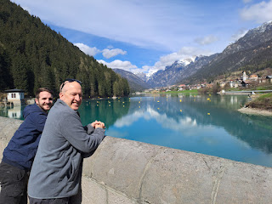

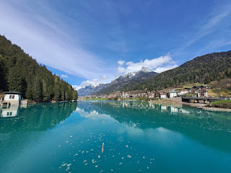

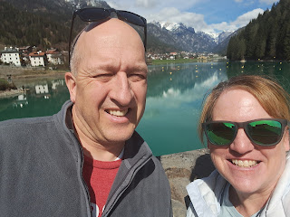

Across the street from the dam, there was a level field where we could try again to launch the drone, now that the firmware was all updated. It went perfectly!!

Video of Scott sending up the drone: (26 seconds)

https://photos.app.goo.gl/BKvLgxCjaQYxXf1q7

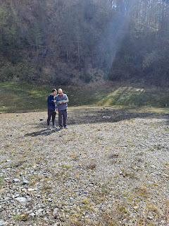

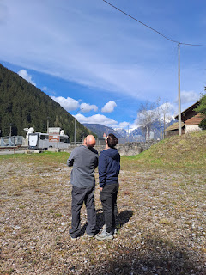

Once he got the hang of it, we walked back over to where the dam was and sent it up a few more times.

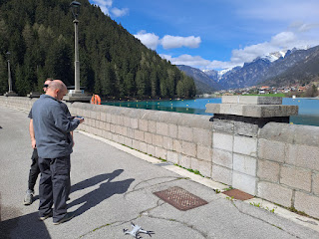

Video of the drone over the dam: (31 seconds)

https://photos.app.goo.gl/osETYovx6yrbJLvU7

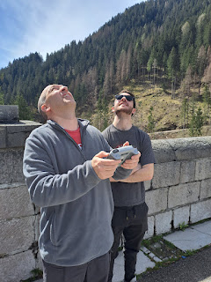

You can just barely see the drone above the mountain in the photo below.

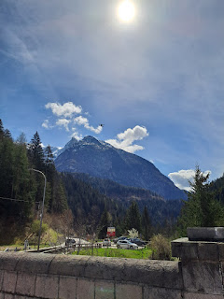

I love this video of Scott teaching his son how to run the drone for the first time. Benson was super excited, but nervous, too. He didn't want to do anything stupid, like send the drone into the lake . . . They both said that it was extremely easy to fly, and that DJI (the company we bought from) makes it VERY easy for first time users. We are so grateful that Benson did all that research and helped us find this brand.

Video of Scott and Benson: (16 seconds)

https://photos.app.goo.gl/rpTvDT9cYYe37F9d8

Next, we drove a little further north. Gordon was up in the front seat and was getting all the best photos of the Dolomites. But Benson was kind enough to lean out the side window and take a couple photos for me as we rode in the back seat.

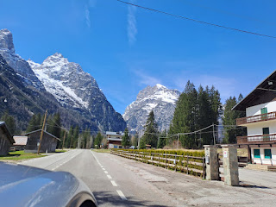

We found a medium sized (and slightly muddy) parking lot on the side of the road where we pulled over once again to launch the drone.

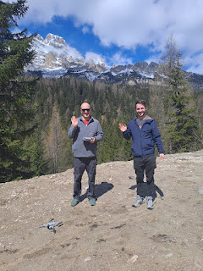

From this vantage point, there were some incredible views for the drone to capture. In the next video, you can hear Scott saying, "Oh my Gosh!!" and Benson saying, "Oh my Goodness!!" ha ha

Short video of the boys: (6 seconds)

https://photos.app.goo.gl/GxDZWvYZ4v1DrKQX8

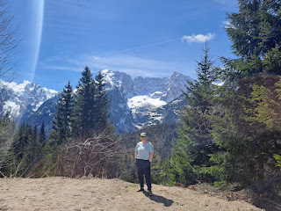

Scott, Benson, and Gordon

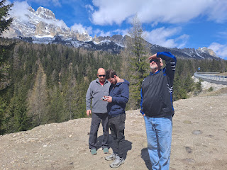

I loved seeing how happy it made Benson to fly the drone. He is a serious photographer, and wants to put together an edited video of all the footage we captured in the Dolomites that day.

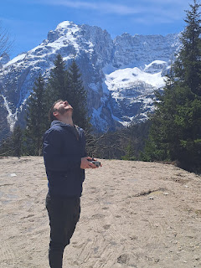

Unfortunately, we weren't able to make it all the way to Tre Cime (Three Peaks), a famous section of the Dolomites. The roads don't open until late May/early June. So we made Lake Misurina our "end destination" for the day. In the photo below, you can see the peaks of Tre Cime slightly to the right of the center. You can also see how the lake was still partially frozen over where we stood . . .

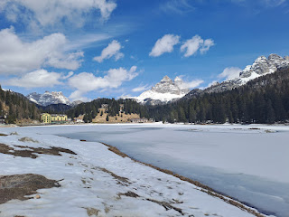

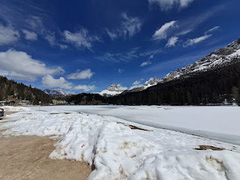

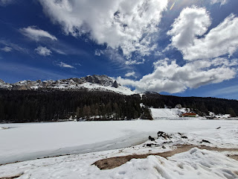

Scott and Benson had a good time flying the drone across the lake and back. It can fly up to 10 km away, but Scott is still learning about all the settings and feels more comfortable to keep it a little closer, ha ha.

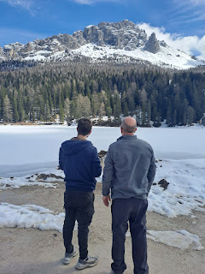

Video of the drone zooming back towards us over the lake: (22 seconds)

https://photos.app.goo.gl/wmFYyoJGtrnyDjb76

Across the street from the lake's edge, was a cute little shop where we could buy a few souvenirs and gifts. I loved all the miniature cuckoo clocks. This area of Italy is VERY close to the Austrian border, and is therefore heavily influenced by Austrian culture, food, architecture, etc.

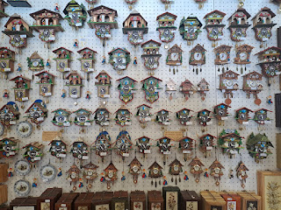

Short video of the cuckoo clocks: (5 seconds)

https://photos.app.goo.gl/VWmKAnN65s9AsEUZ7

In Mexico, they have a siesta in the afternoon. In Italy, they have a riposo. It's the same thing: a time to go home and eat lunch, rest, and be with family for a few hours before going back to finish up. It is very common to see shops and restaurants close up around 12:30 and then they open back up from 3:30 to 6:30 or 7:00.

It does make it a little more difficult to find a place for lunch though, if you aren't paying attention to the time. Many lunch spots close at 2:30, while others close at 12:30, but we were running a little late on time this particular day. It was 2:10 and most places were already closed in town. Thankfully someone recommended a pizzeria for us down the street. It was due to close at 2:30 so we hurried right on over!!

Gordon and Pam, holding hands. So sweet.

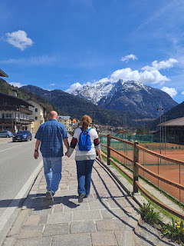

I ordered a pizza called Trevisano. It had turkey on it, along with some marinated radicchio lettuce (the dark burgundy pieces). It was pretty good!

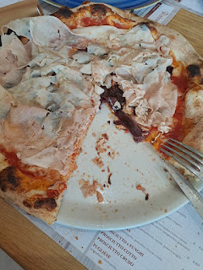

Once our tummies were nice and full, we started driving back to Aviano. We stopped here, in Erto, because it's one of Benson's favorite places. He has driven up these roads numerous times during the 4 years he's lived in Italy. He wanted to get some drone footage of this area to add to the video he plans to put together. (Especially because he leaves soon for Korea)

I thought it was so cute to see another Ceat Leon car parked next to us. My immediate thought was of the song, "Ebony and Ivory" by Paul McCartney and Stevie Wonder. LOL

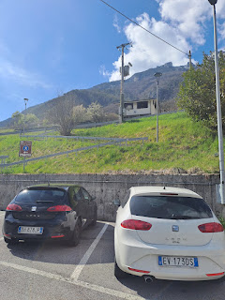

Benson found a nice perch to fly the drone, while Scott called his Mom to share the views with her.

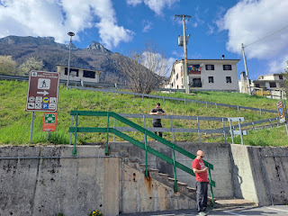

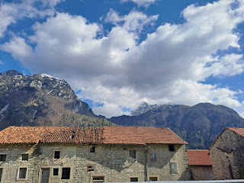

This view was right across the street from us. Gordon and Pam went on a little explore down those narrow steps into the mostly abandoned village.

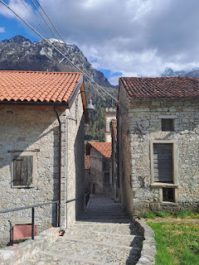

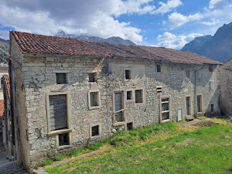

After they had been gone for several minutes, Benson used the drone to "hunt" for them, ha ha. Huff, puff, up those steps they eventually came . . .

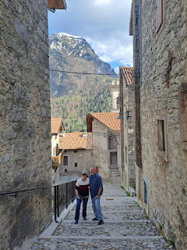

Next stop: Lake Barcis. (pronounced Bar-chiss) This beautiful lake is a bright turquoise that almost seems fake, like someone used PhotoShop in any photos you happen to take. We hopped on a 10 minute and mostly uphill trail that takes you to an overlook of the lake. I went up here once before with Benson and Kylie a few weeks before she had Avery back in the fall of 2021.

Benson with a dramatic pose . . .

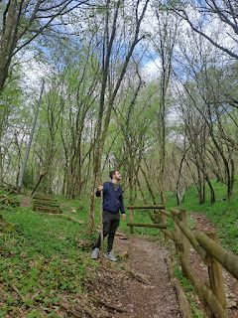

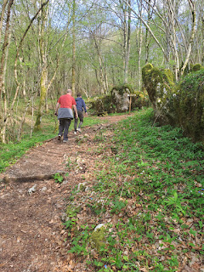

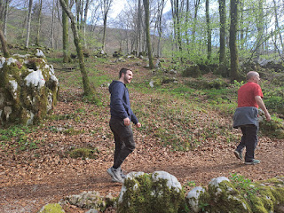

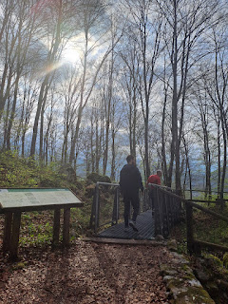

Scott, Gordon, Pam, and Benson

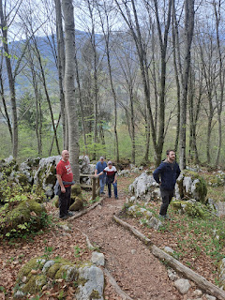

The overlook has a glass bottom so you can see the dam below.

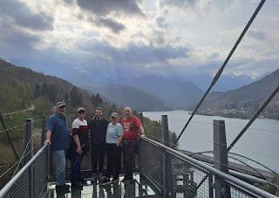

The boys, mostly Benson, had a great time launching rocks down and trying to land them in the water below. It was a difficult feat because the crevasse was narrow and also quite a ways down. They did have a couple of successes.

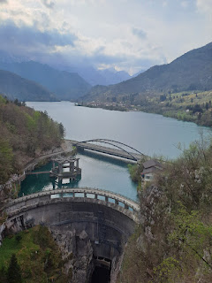

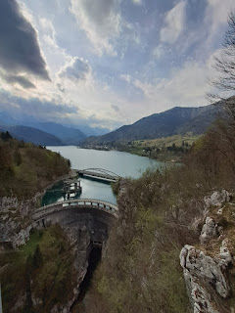

I enjoyed photographing some of the many wildflowers on the way back down the trail.

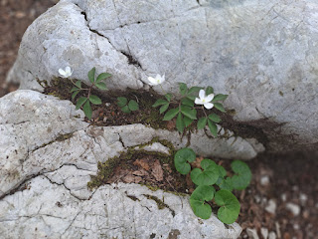

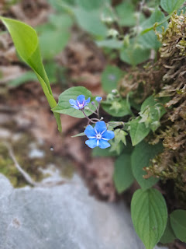

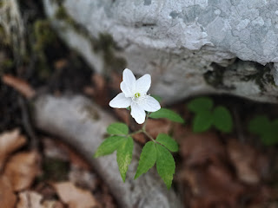

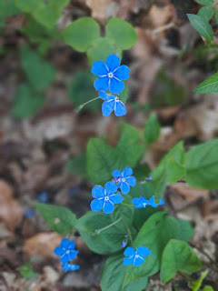

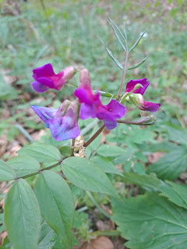

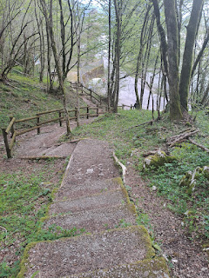

And then it was time to launch the drone again.

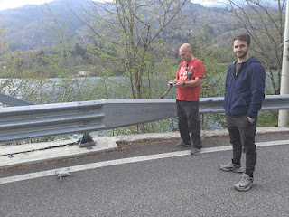

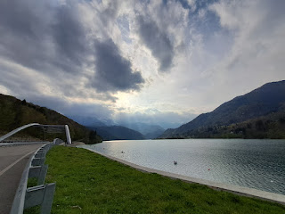

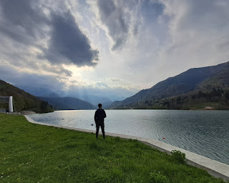

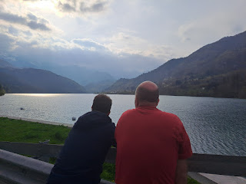

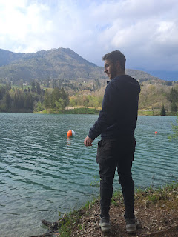

Benson was a little rusty at skipping rocks, but wanted to give it a try. How did he do?

Video of one of his attempts: (4 seconds)

https://photos.app.goo.gl/o6bFYo8Wwuj3NBux6

It was nice to get out of the car so many times on our drive because some of us with wider hips or cranky lower backs in the back seat sure needed it! If we had driven from Vicenza up to Lake Misurina it would have only taken 2 hrs 40 minutes each way. But we needed Benson with us. So we drove 90 minutes up to Aviano and stayed the night. From Aviano it was 2 hours to Lake Misurina. Buuuuut . . . what goes up . . . must come down . . . We drove 2 hours back to Aviano to drop Benson off, and then another 90 minutes back to Vicenza. So all those stops really did help.

Back at Benson's house, we got to see Avery. YAY!! When Kylie opened up the door (she met us there), Avery's face lit up right away when she saw me. Talk about hearts melting . . . And she came right to me and let me carry her around. She got real shy when Gordon and Pam walked in, and then was unsure about going to Poppa (Scott). I'm glad she let me hold her, at least. I have missed her a lot!

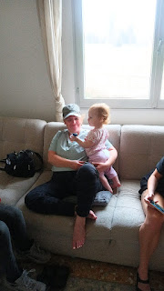

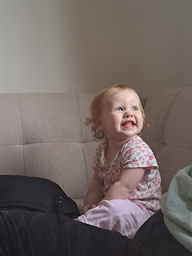

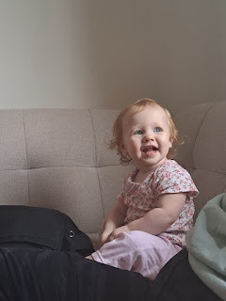

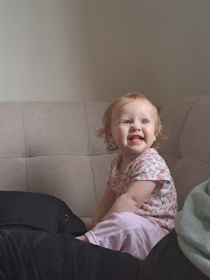

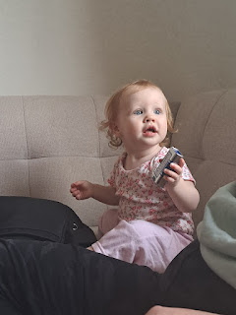

She had a blast emptying out my purse. Hmmm, let's sort things out. Does this one make any noise? Okay, you go over here.

Video of Avery sorting: (47 seconds)

https://photos.app.goo.gl/wGGmupkWJ3B9dnRq5

We were all pretty quiet on the drive home from Aviano. What a long day! But it was a special time with Benson and we saw some spectacular sights.

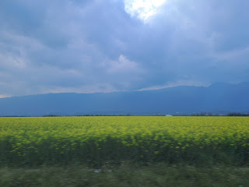

Here is a link to all the drone footage that Scott and Benson captured throughout the day:

https://photos.app.goo.gl/EcPYag9TRi8DxnvKA

Sunday:

Scott and I gave talks in Sacrament Meeting on the topic of Forgiveness. I shared some personal experiences that helped me learn how to forgive and we both received some nice compliments afterwards. Here is the link to mine:

https://docs.google.com/document/d/13qJA8Xvn4uKL0bceO0m17ecVDnTHSSmjE4cYhehtC9o/edit?usp=sharing

This was also Gordon's 57th birthday. His only request was to have a nap. LOL

After a nap and some quiet time, we drove a short distance to show Gordon and Pam the Castles of Romeo and Juliet, about 25 minutes from our house.

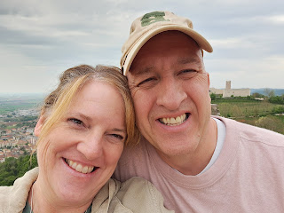

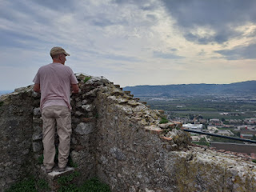

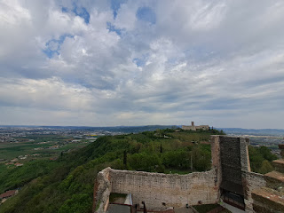

Inside the Castello di Romeo, an older Italian man, perhaps in his 70's, was retelling the story of Romeo and Juliet very animatedly. I took a couple of videos of him because he was just so cute!

Video #1: (1 minute, 28 seconds)

https://photos.app.goo.gl/Dcqq42LCBW8oCxiJA

Video #2: (50 seconds)

https://photos.app.goo.gl/fhqUNr7Xy3uotvzx9

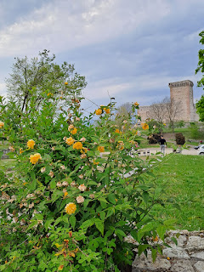

It was a short 5 minute walk over to the Castello di Giulietta.

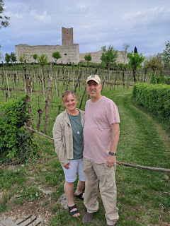

I loved this giant Wisteria attached to the inner castle walls.

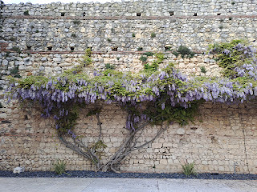

Gordon and Pam

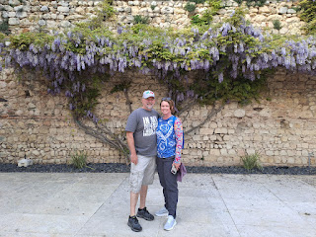

After some sprinkles earlier, the skies were simply majestic that evening!

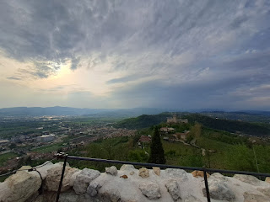

Back down in the parking lot, Scott sent up his drone, but for some reason it wouldn't capture any video this time. So he took a few photos instead, far above the castles. He figured out the problem once we got home, and now everything is okay again. I'm glad he's loving his gift so much! :)

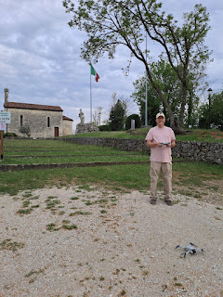

Video of the drone at Romeo's Castle: (13 seconds)

https://photos.app.goo.gl/Nn7hebYXwskDcmuq8

When we got home, Pam and I put together some tasty chicken soup, using a little of this and a little of that in the fridge, including some pasta leftovers, and some fresh and frozen vegetables. Then we put a couple of candles in a PB bar and sang Happy Birthday to Gordon. They are planning a larger family celebration when they get home to West Virginia.

Video of the Happy Birthday Song, including Gordon's spunky additions: (24 seconds)

https://photos.app.goo.gl/msAFxL882uPCMuWaA

Monday:

We drove over to Verona to show them the Arena di Verona (a Roman Colosseum very well preserved and dating back to 30 AD), but unfortunately it was under construction and was CLOSED!! So we just walked around the exterior and took some pictures.

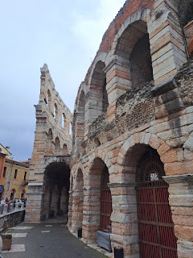

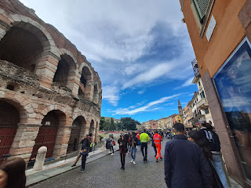

Scott and I paused here on a side street so that we could take care of a purchase online that was giving us a little bit of trouble. We were trying to book a 2 hour ticket (times 4) to visit the AquaGardens after we left Verona. You can only do it online and not in person. Scott found a pleasant table to sit down and get it all taken care of.

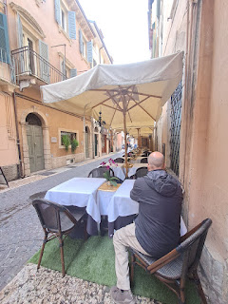

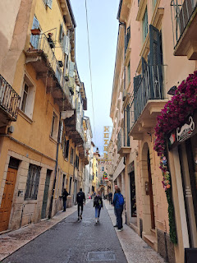

Gordon and Pam had fun just wandering the streets and soaking it all in. Short video of them: (16 seconds)

https://photos.app.goo.gl/H8tcTAEPx3PN36u56

It took us a long time to find a place for lunch near the Arena. First of all, the crowds were astronomical! Secondly, we didn't know that Monday was lumped into Tuesday's big holiday known as Liberation Day (celebrating the day that Italy was liberated from Nazism and Fascism on 25 April 1945). Everyone was in Verona it seemed. Thirdly, many places are closed for the entire day on a national holiday. It's also difficult to choose a restaurant when you have more than 1-2 people . . . Scott wasn't hungry because he had a big breakfast and he's not much of a lunch eater. Gordon was hungry, and so was I. My only criteria was that we find a place with some protein, not just pizza or pasta. Pam wasn't crazy about the burger place we finally settled on, Hard Rock Cafe, but she was a good sport and found something to eat from the menu.

I ordered the Caesar Salad with grilled shrimp. Yum!

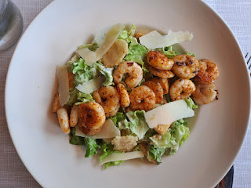

Afterwards, I grabbed a dark chocolate and pistachio gelato around the corner, and then ate it as we walked a short distance to see the river.

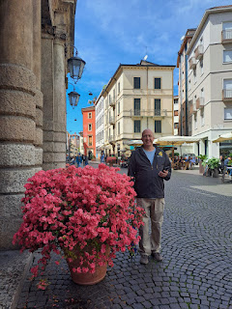

Scott and I visited this castle last fall in Verona. It's known as Castelvecchio and was built in the 14th century. It's huge!

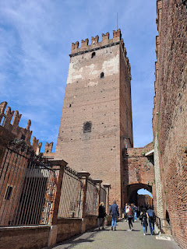

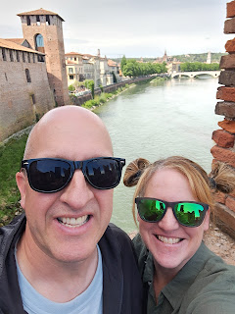

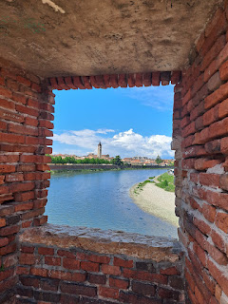

Two brothers, aka mountain goats - who shimmied up the narrow steps to get to this perch . . .

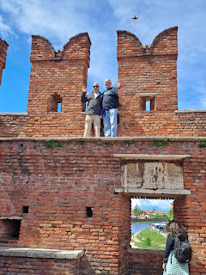

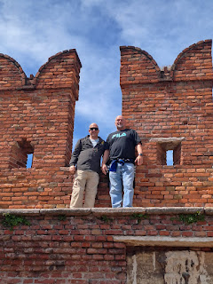

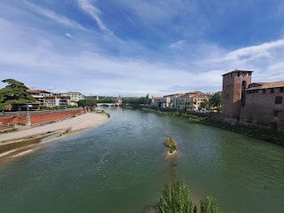

On the short 5 minute walk back to our parking garage, we passed some colorful arrangements of springtime flowers.

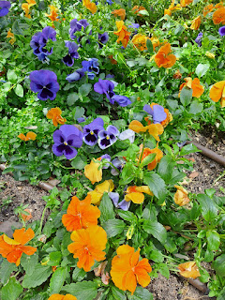

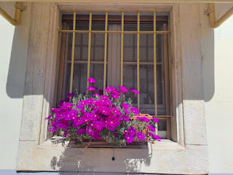

Next, we drove about 25 minutes NW to Aquardens. Yes, that is spelled correctly. We always pronounce it AquaGardens, but it's all the same place. This was only our second time coming here, but we just love it! We want to bring all of our guests here . . .

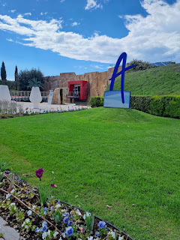

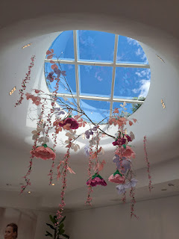

After you've changed out of street clothes and you're ready to hop into one of the MANY warm mineral pools, there are lots of caves and shortcuts to get where you're going.

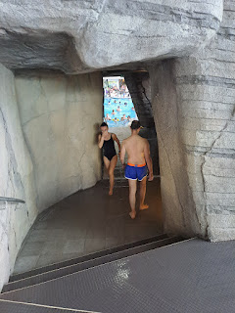

We love the outdoor pools the most because of the fresh air.

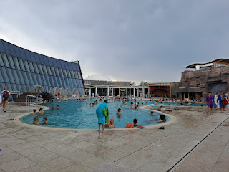

They have 3 large enclosed "bubble tents" outside, with toys and all sorts of things for the little ones to play on or with.

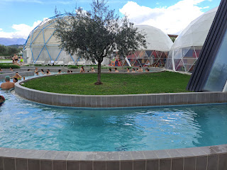

We love the lazy river where you can just float around and around for days. The sky was looming with some dark clourds, but it didn't rain on us while we were there. AquaGardens is open rain or shine 365 days a year.

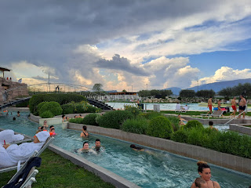

In the photo below, the large pool on the right is a cold pool, and COLD IT IS!! The first time I got in, it was just shocking how cold it was. But the 2nd and 3rd time, I was just fine. Scott told me that I was very brave. When he hopped in, with me encouraging him, he almost screamed like a little girl, ha ha.

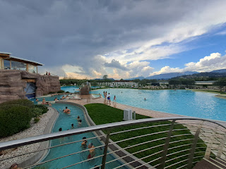

There is also an area indoors where you can apply a few different types of mud masks, and then rinse it off once it has hardened. Maybe I'll try that next time.

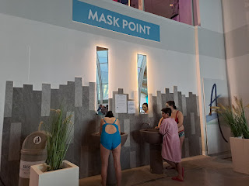

Gord and Pam, relaxing together in the pool.

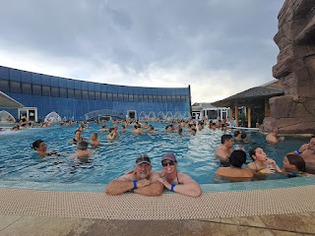

These plastic hanging things separate the indoors from the outdoors if you want to venture into one of the caves.

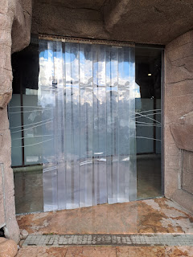

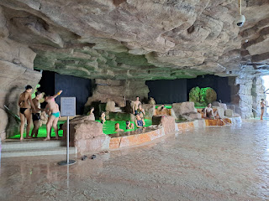

I wish we could come here every weekend . . .

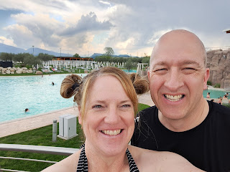

This is a map of the entire establishment. Yep, it's big.

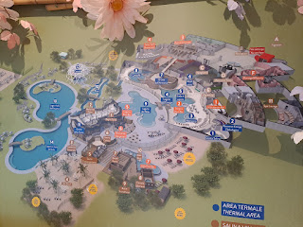

Once Scott and I got dressed and were waiting for Gordon and Pam, I was in awe of how precious this scene was across the hall. The dad was using a blowdryer on his daughter's hair, while the mom was brushing out all of her tangles. Meanwhile, the girl was watching something on a cellphone, ha ha. Seriously, though, how sweet that it was a whole "family affair".

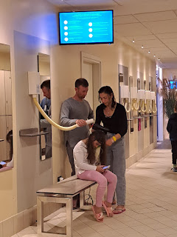

On the way home, we really appreciated seeing this rainbow, even though it is exremely faint and you may not even see it in the photo. But we did. There were several signs yesterday that all will be okay in this world, even when there are some tough things going on at the same time.

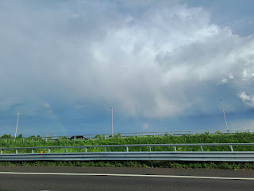

Something surprising also happened halfway home . . . HAIL. Hail happened.

Video: (23 seconds)

https://photos.app.goo.gl/1QT8yMkzvLe8FqPc8

We even saw a guy pull over to the side of the road to put plastic sheeting over his BMW to protect it, LOL.

After we got back into town, we went a little out of our way to see if the same field of poppies that we saw last spring was in bloom yet. It wasn't. But we found a very small patch of pretty blooms, and some gorgeous calla lilies nearby.

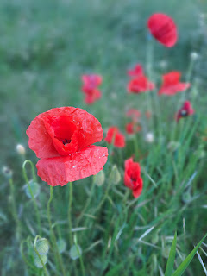

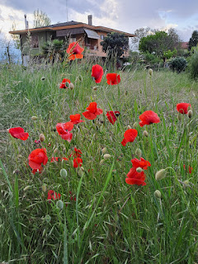

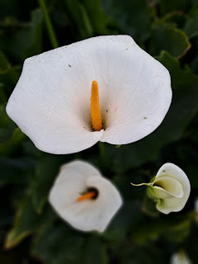

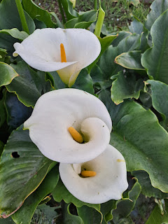

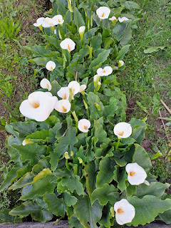

Another beautiful thing that we saw on the way home was this . . .

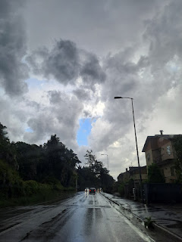

What made it so significant is that Gordon said, "Hey, Mom always called that little blue patch a Cloud Scooper!" We had just been thinking about her, as a matter of fact. Gordon and Scott ventured a guess that Coy's father may have taught that phrase to her when she was growing up and then she passed it down to them. How precious.

Another beautiful sign of God's love for us was this sunset that we were privileged to witness at the end of the day.

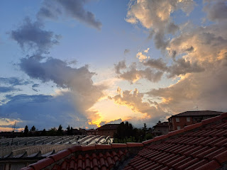

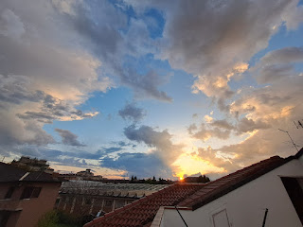

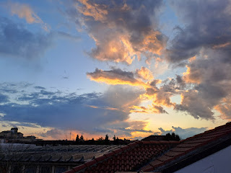

Scott called his mom to show it to her and to let her know that he was thinking of her.

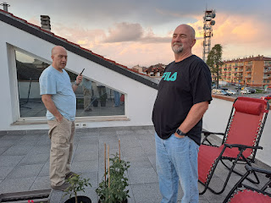

It was such a beautiful time for these two brothers to be together for 10 days, over the course of both of their birthdays, and through the emotional roller coaster of some sad family news from afar.

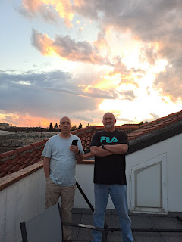

Tuesday:

After a hearty breakfast, I drove Gordon and Pam through a heavy downpour to the Venice Airport. I dropped them off near the water taxi docks where they would be catching a ride out to Murano, one of the islands out by Venice in the Lagoon. They'll spend the night out there tonight and then fly back to the United States tomorrow.

One last brotherly hug. Cuz brothers gotta hug. :)

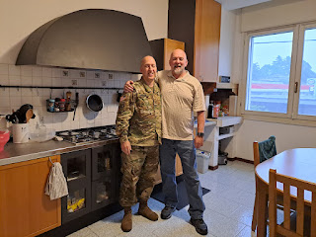

And off they go . . .

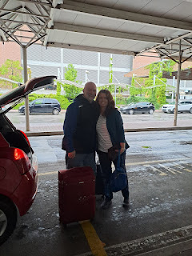

The rest of the day was spent working on this blog or catching up on several phone calls. It's almost 10:00 p.m., but I have one last thought I want to share.

Our Father in Heaven loves us. Jesus Christ loves us. We felt that in several ways yesterday.

1. The rainbow. Even though it was faint and barely visible in the photo, it was still there. The skies were overcast, but there was a large rainbow that was clearly visible to everyone for miles around. It was profound in size.

2. The tiny patch of brilliant blue amid the darkened and cloudy skies. It may have seemed small, but it was still there. And it was profound in contrast.

3. The poppies. We had hoped for a large field of blooming poppies, and only found a small grouping instead. But they were still there. And they were profound in beauty.

4. The sunset. We wanted to share its beauty with Scott's mom in a video call, however, she couldn't see it because of a technical issue. But it was still there. And it was profound in every way, even the part where we simply just connected with her from the other side of the world.

In each case, we had an expectation. Maybe we wanted more blue skies, rather than stormy skies. But the evidence of God's love was always there. That's because He IS always there. We just might need to look a little harder for Him. That's when we will find Him.